

East West University

Department of Computer Science and Engineering
Semester : spring 2021

Course Title: Electrical Circuits
Course Code: CSE 209
Section: 03

Experiment No: 02
Experiment Title: Series – Parallel DC Circuit and Verification of Kirchhoff’S Laws

Student Name: Md. Rakibur Rahman
ID: 2019-3-60-113

Date of Performance: 22.03.2021
Date of Submission: 28.03.2021

Objectives:
- To learn analysis of dc series-parallel circuit.
- To verify Kirchhoff’s voltage law (KVL).
- To verify Kirchhoff’s current law (KCL).

Circuit Diagram:

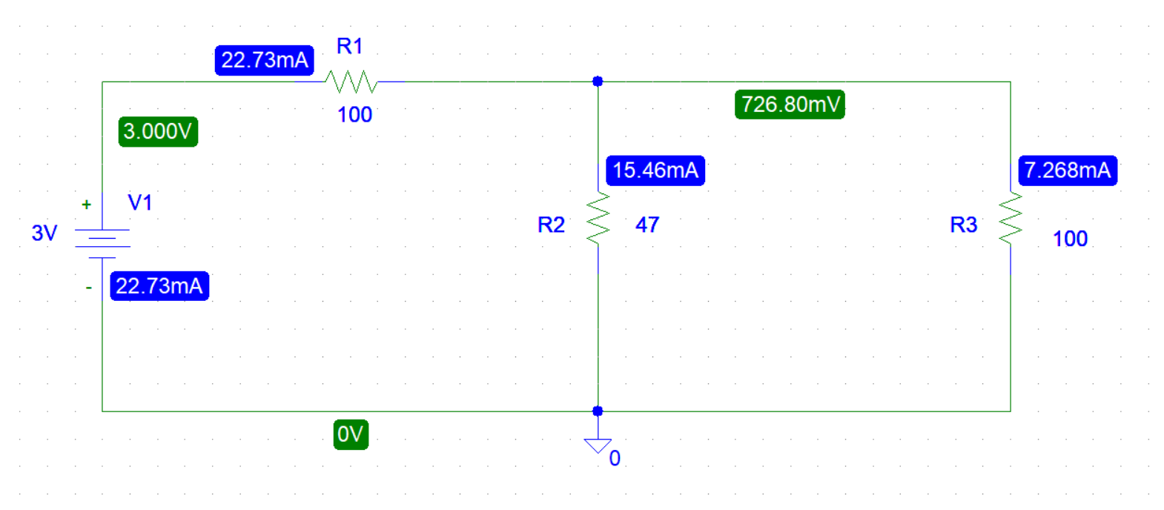

Measured Value of E(V) | Measured Value of V₁ (V) | Measured Value of V₂ (V) | Measured Value of V₃ (V) | Measured Value of I₁(mA) | Measured Value of  I₂(mA) | Measured Value of  I₃(mA) | Measured Value of Resistance(Ω)
3 | 3 | 0.7268 | 0.7268 | 22.73 | 15.46 | 7.268 | R₁=100 Ω  R₂=47Ω  R₃=100 Ω
Experimental Datasheet:

Answers to the post lab report questions:

- Here , R₂ and R₃ are parallel,

So, Equivalent resistance, Rp= $\frac{47×100}{47+100}=31.973$Ω
Applying voltage divider rule,
V₁=$\frac{E}{R1+Rp}$ $×$ R₁
=$\frac{3}{100+31.973}×100$
= 2.273V
V₂ =$\frac{E}{R1+Rp}$ $×$ Rp
=$\frac{3}{100+31.973}×31.973$
= 0.727V
Here , V₂ and V₃ are parallel.

So , V₂ = V₃ = 0.727V . Because the voltage is equal in Parallel Circuit .

From Ohm’s Law,
I₁=$\frac{E}{R1+Rp}$
= $\frac{3}{100+31.973}$
= 0.02273A
= 22.73mA
Applying current divider rule,
I₂=$\frac{I1}{R2+R3}$ $×$ R₃
= $\frac{22.73}{47+100}×100$
= 15.463mA
I₃=$\frac{I1}{R2+R3}$ $×$ R₂
= $\frac{22.73}{47+100}×47$
= 7.267mA

Comparing the theoretically calculated values with the simulated values from PSpice.

 | Calculated value | Measured value
Current | I₁ =22.73mA | I₁ =22.73mA
 | I₂= 15.463mA | I₂ =15.46mA
 | I₃= 7.267mA | I₃= 7.268mA
Voltage | V₁ = 2.273V | V₁ = 3V
 | V₂ = 0.727V = 727mV | V₂ = 726.80mV
 | V₃ = 0.727V = 727mV | V₃ = 726.80mV

The experimental values of the voltages and the currents are slightly different from the theoretical values.

- (i) From the calculated values we get,
V₂ = V₃ = 0.727V
Here, both V₂ and V₃ are parallel in the circuit so the
voltage are same.
(ii) From the calculated values we get,
V₁ = 2.273V
V₂ = 0.727V
Applying KVL,

V₁+V₂ = (2.273+0.727)V
= 3V
= E

(iii) From the calculated values we get,
I₁ = 22.73mA
I₂ = 15.463mA
I₃ = 7.267mA
Applying KCL,
I₂+ I₃ = (15.463+7.267)mA
= 22.73mA
= I₁

Conclusion:
From the experiment we learnt about the application Ohm’s Law, Kirchhoff’s Voltage Law(KVL) and Kirchhoff’s Current Law(KCL).

